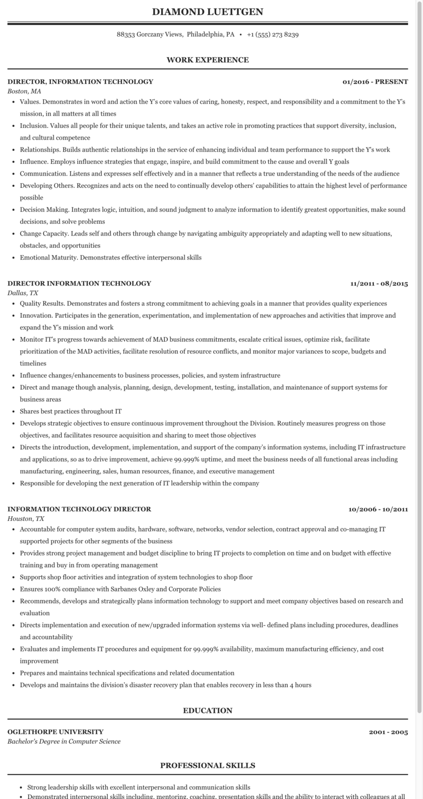
DIAMOND LUETTGEN
88353 Gorczany Views, Philadelphia, PA +1 (555) 273 8239
WORK EXPERIENCE
DIRECTOR, INFORMATION TECHNOLOGY
Boston, MA
01/2016 - PRESENT
• Values. Demonstrates in word and action the Y's core values of caring, honesty, respect, and responsibility and a commitment to the Y's mission, in all matters at all times
⚫ Inclusion. Values all people for their unique talents, and takes an active role in promoting practices that support diversity, inclusion, and cultural competence
• Relationships. Builds authentic relationships in the service of enhancing individual and team performance to support the Y's work
⚫ Influence. Employs influence strategies that engage, inspire, and build commitment to the cause and overall Y goals
• Communication. Listens and expresses self effectively and in a manner that reflects a true understanding of the needs of the audience
• Developing Others. Recognizes and acts on the need to continually develop others' capabilities to attain the highest level of performance possible
⚫ Decision Making. Integrates logic, intuition, and sound judgment to analyze information to identify greatest opportunities, make sound decisions, and solve problems
⚫ Change Capacity. Leads self and others through change by navigating ambiguity appropriately and adapting well to new situations, obstacles, and opportunities
⚫ Emotional Maturity. Demonstrates effective interpersonal skills
DIRECTOR INFORMATION TECHNOLOGY Dallas, TX
11/2011-08/2015
• Quality Results. Demonstrates and fosters a strong commitment to achieving goals in a manner that provides quality experiences
• Innovation. Participates in the generation, experimentation, and implementation of new approaches and activities that improve and expand the Y's mission and work
• Monitor IT's progress towards achievement of MAD business commitments, escalate critical issues, optimize risk, facilitate prioritization of the MAD activities, facilitate resolution of resource conflicts, and monitor major variances to scope, budgets and timelines
• Influence changes/enhancements to business processes, policies, and system infrastructure
⚫ Direct and manage though analysis, planning, design, development, testing, installation, and maintenance of support systems for business areas
• Shares best practices throughout IT
• Develops strategic objectives to ensure continuous improvement throughout the Division. Routinely measures progress on those objectives, and facilitates resource acquisition and sharing to meet those objectives
• Directs the introduction, development, implementation, and support of the company's information systems, including IT infrastructure and applications, so as to drive improvement, achieve 99.999% uptime, and meet the business needs of all functional areas including manufacturing, engineering, sales, human resources, finance, and executive management
• Responsible for developing the next generation of IT leadership within the company
INFORMATION TECHNOLOGY DIRECTOR Houston, TX
10/2006 - 10/2011
• Accountable for computer system audits, hardware, software, networks, vendor selection, contract approval and co-managing IT supported projects for other segments of the business
• Provides strong project management and budget discipline to bring IT projects to completion on time and on budget with effective training and buy in from operating management
• Supports shop floor activities and integration of system technologies to shop floor
• Ensures 100% compliance with Sarbanes Oxley and Corporate Policies
• Recommends, develops and strategically plans information technology to support and meet company objectives based on research and evaluation
⚫ Directs implementation and execution of new/upgraded information systems via well-defined plans including procedures, deadlines and accountability
• Evaluates and implements IT procedures and equipment for 99.999% availability, maximum manufacturing efficiency, and cost improvement
• Prepares and maintains technical specifications and related documentation
• Develops and maintains the division's disaster recovery plan that enables recovery in less than 4 hours
OGLETHORPE UNIVERSITY
Bachelor's Degree in Computer Science
•
EDUCATION
PROFESSIONAL SKILLS
2001-2005
Strong leadership skills with excellent interpersonal and communication skills
Demonstrated interpersonal skills including, mentoring, coaching, presentation skills and the ability to interact with colleagues at all.

